BUDO JUNIOR SCHOOL
REMEDIAL WORK FOR TERM 1 2020 - SET TWO
LITERACY I – PRIMARY THREE
Time allowed: 1hour

Name : _____________________________________________________
Stream : _________________ Date:_____________________

SECTION A:
1. Where does the sun rise from?
________________________________________________________________
2. Name one component of soil.
________________________________________________________________
3. Write down any one local means of communication.
________________________________________________________________
4. How does a chameleon protect itself?
________________________________________________________________
5. Mention the commonest type of transport used in your sub-county.
________________________________________________________________
6. Name the biggest component of air.
________________________________________________________________
7. What is the biggest ethnic group of your sub-county?
________________________________________________________________
8. Mention any one domestic animal.
________________________________________________________________
9. Give any one reason why we should use map symbols on a map.
________________________________________________________________
10. Which body organ is used for seeing?
________________________________________________________________

11. Mention any one building material you know.
________________________________________________________________
12. List one item found in the first aid box.
________________________________________________________________
13. How is a dentist important in our sub country?
________________________________________________________________
14. Name one type of weather.
________________________________________________________________
15. Who is responsible for children’s affairs on the Local Council committee?
________________________________________________________________
16. What is air?
________________________________________________________________
17. Identify any one quality of a good leader.
________________________________________________________________
18. What do we call the medium on which plants grow?
________________________________________________________________
19. Mention any one type of fish caught in Uganda.
________________________________________________________________
20. Give one activity a farmer can do during the dry season.
________________________________________________________________
21. How is Lake Katwe important to the people of Uganda?
________________________________________________________________
22. Give one item used to clean the mouth.
________________________________________________________________
23. Write down any one challenge of education services in our sub-county.
________________________________________________________________
24. Name any one natural change in the environment.
________________________________________________________________
25. How is a compass useful to a pilot?
________________________________________________________________
26. Which component of air occupies 0.03% in the atmosphere?
________________________________________________________________
27. Identify any one organ that provides security services.
________________________________________________________________
28. Name the property of air below.
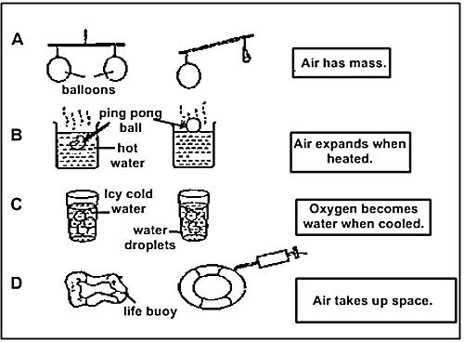

________________________________________________________________
29. How are economic activities important to the people of your
Sub-county?
________________________________________________________________
30. Name the component of soil which has life.
________________________________________________________________
31. Mention any one way of finding direction of a place.
________________________________________________________________
32. Which type of soil has the smallest particles?
________________________________________________________________
33. How do we call a group of villages?
________________________________________________________________
34. Give any one importance of swamps.
________________________________________________________________
35. Draw and name one item found in the first aid box.

________________________________________________________________
36. Why does a potter bake his items in a kiln?
________________________________________________________________
37. What is food?
________________________________________________________________
38. In which season do farmers plant crops?
________________________________________________________________
39. What is the main occupation of the Baganda?
________________________________________________________________
40. How is burning similar to rusting.
________________________________________________________________

SECTION B:
41.a) Draw the map of the following object.
a tree | a pot
b) Write down any two elements of a good map.
(i)______________________ (ii)__________________________

42. Mention 4 ways how you can control the spread of COVID-19.
i.____________________________________________________________
ii.____________________________________________________________
iii.____________________________________________________________
iv.____________________________________________________________

43.a) Name the directions marked a , b , c
c

b

a
b) What name do we give to the instrument above?
______________________________________________________________

44.a) Who is a farmer?
_______________________________________________________________
b) Identify any two needs of a farmer.
i) ______________________________________________________________
ii) _____________________________________________________________
c) Give any one problem faced by farmers in your sub-county.
_______________________________________________________________

45.a)Give any two examples of health centres you know.
i) ______________________________________________________________
ii) _____________________________________________________________
b) Write down any two reasons why people go to health centres.
i) ______________________________________________________________
ii) _____________________________________________________________

46.a) Why do animals move from one place to another.
i) ______________________________________________________________
ii) _____________________________________________________________
b) Name the animal that give us ;
i) beef - ______________________ ii) pork - ______________________
47.a) How do we call the vertical arrangement of soil layers?
______________________________________________________
b) Which layer is the best for growing crops?
___________________________________________________________
c) Name any two types of soil.
I._____________________________ ii.__________________________

48. The diagram shows the component of air.

AA

a. Name the components of air with the largest percentage.
_______________________________________________________________
b. Give one use of component of air.
_______________________________________________________________

49.a) Match the following.
Animal young one
cow chick
hen kid
goat kitten
rabbit calf

50. 50a) What is a map? ______________________________________
___________________________________________________________
b) Write down three elements of a good map.
i) _________________________________________________________
ii) _________________________________________________________
iii) ________________________________________________________
51.a) Give any two ways how people preserve fish in your sub-county.
i) ______________________________________________________________
ii) _____________________________________________________________
b. Mention any two methods of catching fish.
(i) _____________________________________________________________
(ii) ____________________________________________________________

52.a) State any two examples of physical features you know.
i) ______________________________________________________________
ii) _____________________________________________________________
b. Write down any two activities done around physical features.
i) ______________________________________________________________
ii) _____________________________________________________________
53. Write the following in full.
i) L.C. - _____________________________________________________
ii) U.P.E - ______________________________________________________

54. Write down any two characteristics of living things.
i) ______________________________________________________________
ii) _____________________________________________________________

b) Draw these living things.
animal | bird

55.a) Write down any two man made changes in the environment.
i) _____________________________________________________________
ii) _____________________________________________________________
b) Mention any two effects of man made changes.
i) _____________________________________________________________
ii) _____________________________________________________________
c) Name any two agents of soil erosion.
i) ______________________________________________________________
ii) _____________________________________________________________

